Lesson 1: Dilations
II. Dilations
A_________________________________
is a transformation which changes the size of a figure but not its shape. This reduces or enlarges the figure to a similar figure.
___________________ is the original figure before a transformation is applied.
___________________ is the resulting figure after the dilation.
Write an ordered pair for each coordinate, and then write the transformation from the pre-image to the image
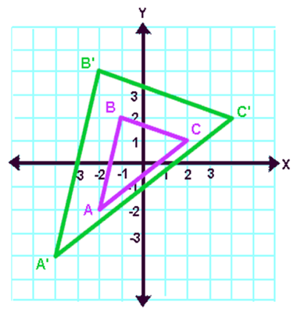
Pre-Image: _____________
_____________

Image: _____________
_____________

Transformation:
____________
______________________
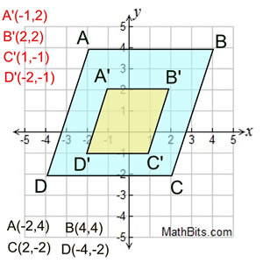
Pre-Image:
_______________
_______________
Image:
_______________
_______________
Transformation:

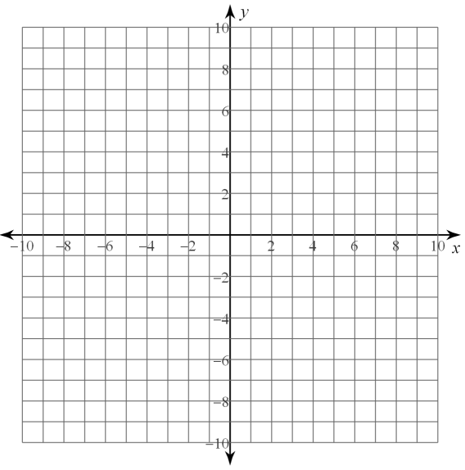
- Graph and connect the points $(2, 2), (3, 4), (5, 2)$ and$(5, 4).$

Graph a new figure on the same coordinate plane with a scale factor of 2.
- Graph a new figure on the same plane with a scale factor of ½. Compare all 3 of the figures. __________________________________________________________________
- What happens when you apply a scale factor of greater than 1? __________________________________________________________________

What happens when you apply a scale factor of less than 1? __________________________________________________________________

Find the coordinates of each transformation and graph the image
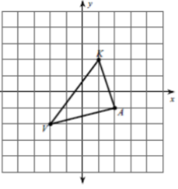
- Dilation of 1.5

- Dilation of 2
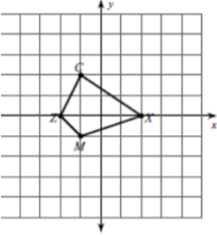

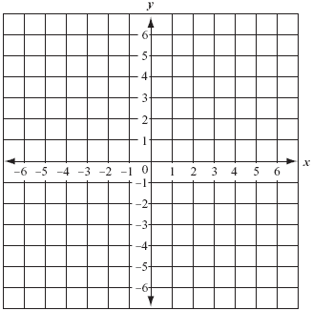
- Write a rule to describe the transformation. S(1, 4), X(0, 5), F(5, 4), E(1, 2) to E’(0.5, 1), X’(0, 2.5), S’(0.5, 2), F’(2.5, 2)

