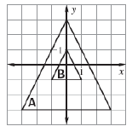
Determine whether the dilation from Figure A to figure B is a reduction or an enlargement. Then find the scale factor, k.

1.
REDUCTION or ENLARGEMENT
k = _____

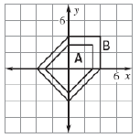
2.
REDUCTION or ENLARGEMENT
k = _____

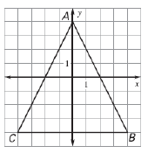
Draw the dilation given the scale factor.
3. k=1/4

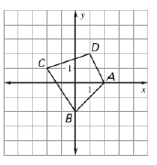
4. k=1.5

Lesson 1: Practice

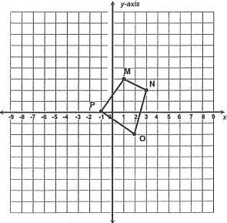
5. Graph the dilated image of quad. MNOP using a scale factor of 3.

M’______ N’_______
O’______ P’_______

6. Graph the dilated image of quadrilateral MNOP using a scale factor of 1/3
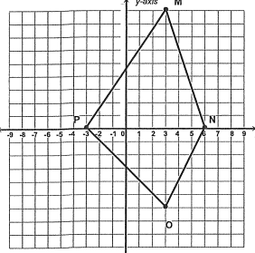

M’______ N’_______
O’______ P’_______

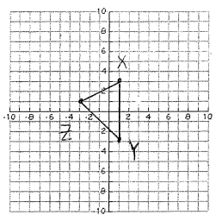
- Graph the dilated image of triangle XYZ using the scale factor of 5/2.

X’______ y’______ Z’______

A and B are endpoint of$\overline{AB}$. Complete the coordinates of C and D, the endpoints of the image after the dilations of scale factor k.

- A(1, 1), B(3, 1), k=2
(x, y) (2x, 2y) A (1, 1) C(____,____)

B (3, 1) D(____, ____)

- A(4, 4), B(8, 12), k=$\frac{3}{4}$
(x, y) ($\frac{3}{4}x, \frac{3}{4}y)$ A (4, 4) C(____,____)

B(8, 12) D(___,____)

