**Lesson 2-Translations**

**I. Vocabulary:**

* An operation that maps or moves the points of a figure in a plane is a ________________________________
* The _____________________________ is the original figure before a transformation is applied.
* The new figure formed by a transformation is the ______________.
* A transformation in which the pre-image and image are congruent is called an **______________________________.**
* The transformation, ________________________________, occurs when a figure is moved by sliding it up, down, left or right.

**I. Translations**

Write the transformation applied to each in two different ways:

* 1. _____________________________

Coordinate Form:__________________

Vector Form: _____________________



2. _________________________________ Coordinate Form:__________________

Vector Form: _____________________



**Graph the image requested using the given Transformation.**

3. <3, 1>

4. (x – 1, y + 3)



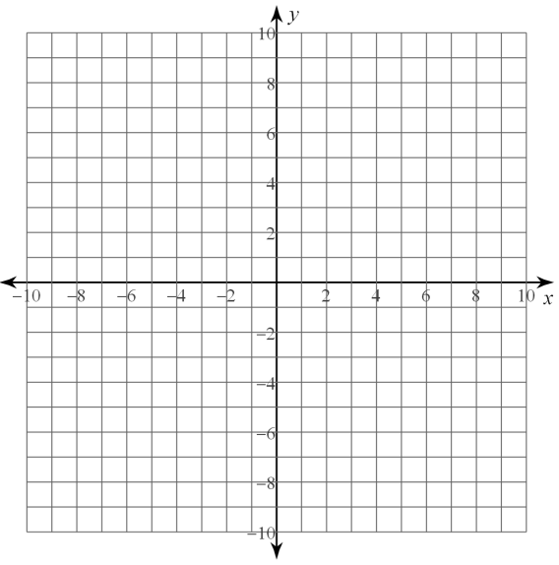5. Graph pentagon *PENTA* with vertices *P*(1, 0), *E*(2, 2), N(4,2), *T*(4, –1), and *A*(2, –2) along the vector 〈–5, –1〉.

**You TRY!**

6. Graph with vertices G(-4, -2), H(-4, 3), J(1, 3), and K(1, -2) along the vector <2, -2>. Label the correct coordinates of $∎G'H'J'K'$