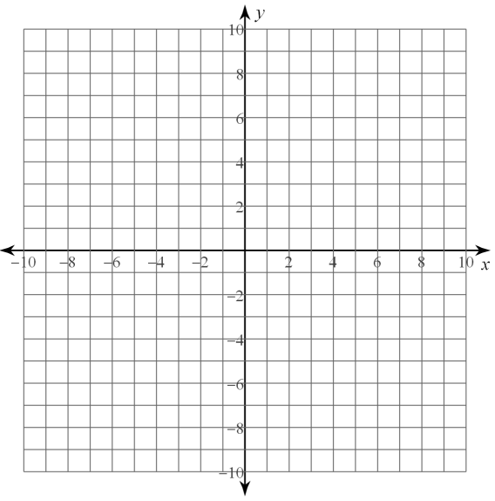
- Graph and connect the points (-2, -2), (0, 5), and (4, 1), then translate the points along the vector <-3, 4>

- Graph and connect the points Z(-4, -3), I(-2, -2), V(-2, -4), then translate the image (x+3, y+4)

LESSON 2: PRACTICE

- Translation: 1 unit left and 2 units up
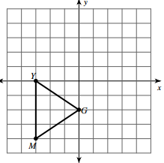

- Translation <0, -3>
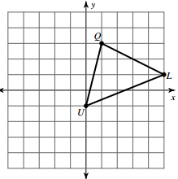

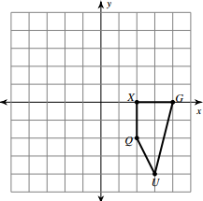
- Translate (x+1, y)

Write a rule to describe each transformation. State the 3 different ways that it can be described

- _____________________________
_____________________________


 


