Lesson 3: Reflections
Vocabulary

- ________________________________ are like mirror images as seen across a line (or a point)
I. Reflections
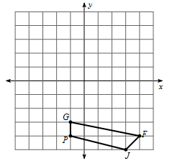
- Reflect the shape over the x-axis.

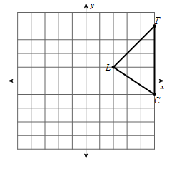
2. Reflect the shape over the y-axis.

When reflecting a shape over x-axis:
___________________________________
When reflecting a shape over the y-axis:
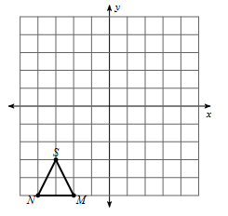
___________________________________
3. Write the ordered pairs to reflect the point $(-3,7)$ and $(10, -2)$ over:
a. the y-axis _____________________
b. the x-axis ____________________
What if we want to reflect over a line? __________________________________

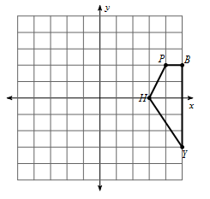
4. Reflect over the line x = 1

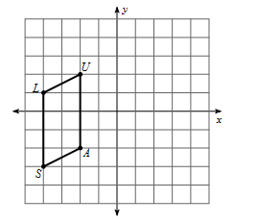
5. Reflect over the line x = -2

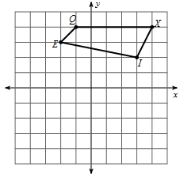
6. Reflect over the line y = 2

7. Reflect over the line y = -1

8. Reflect over the line y=x

9. Reflect over the line y=-x

