1. Reflection across $y=1$



1. Reflection across the x-axis



1. Reflection across $y=-x$

**LESSON 3: PRACTICE**

1. Reflection across $x=-2$

Describe the rules in the following example.

1. _______________________________



1. ______________________________

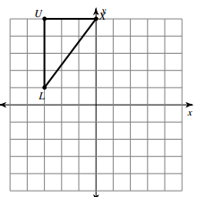7. Reflect across y=3

8. Reflect across the x-axis

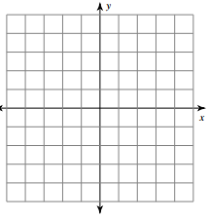 T(2, 2), C(2, 5), Z(5, 4), F(5, 0)

13. Reflect across x=3

 F(2, 2), W(2, 5), K(3, 2)